iNTERN PLACEMENT OFFICE SYSTEM

Software Requirement Specification And Analysis

**Intern Placement Office System**

**Course Name**

Software Project Lab II

**Course No**

SE 505

**Submitted to**

Sheikh Muhammad Sarwar

Assistant professor

and

Md. Asif Imran

Lecturer

**Name of the supervisor**

Md. Nurul Ahad Tawhid

Assistant Professor

**Submitted by**

Md. Sakib Rezoan (BSSE 0611)

**Submission Date**

April 13, 2016



**Institute of Information Technology**

**University of DhakaLetter of Transmittal**

13th April 2016

Md. Asif Imran

Lecturer

IIT, University of Dhaka

Dear Sir,

I have prepared the report on Software Requirements Specification of **‘**Intern Placement Office System**’** for your approval. This report details the requirements I gathered for the project.

The primary purpose of this report is to summarize my findings from the work that I completed as my Software Project Lab II course project. This report includes the details of each step I followed to collect the requirements excusable point.

Sincerely yours

Md. Sakib Rezoan (BSSE0611)

**Executive Summary**

An Intern Placement Office System (IPOS) is proposed by IIT, University of Dhaka (DU) for all students and stuffs associated with internship system. It is a web based software where an admin panel control the system to allocate students for companies. The students can view the notice and information of companies, fill up their choice form and upload their CV. The regular program officer uploads students CGPA only. The Intern placement office head have the authority to access all information.

**Acknowledgements**

By the grace of Almighty Allah, I have completed my report on Software Requirements Specification of Intern Placement Office System of IIT, University of Dhaka. I am grateful to my honorable sir Md. Nurul Ahad Tawhid for his supervision throughout the working time. He helped me a lot by sharing his invaluable knowledge with me. I am also thankful to all the stuff and senior brothers of IIT, DU. They greatly helped me collecting information among all business.

Contents

Chapter 1 Introduction 9

1.1 Purpose 9

1.2 Intended Audience 9

Chapter 2 Inception 10

2.1 Introduction 10

2.1.1 Creating a preliminary scenario 10

2.1.2 Identifying Stakeholders 10

2.1.3 Recognizing multiple viewpoints 11

2.1.4 Working towards collaboration 11

2.1.5 Asking the first question 12

2.2 Conclusion 12

Chapter 3 Elicitation 13

3.1 Introduction 13

3.2 Eliciting Requirements 13

3.2.1 Collaborative Requirements Gathering 13

3.2.2 Quality Function Deployment 13

3.2.3 Usage scenario 14

3.2.4 Elicitation work products 15

Chapter 4 Scenario-Based Modeling 16

4.1 Introduction 16

4.2 Use Case Scenario 16

4.3 Use Case Diagram 17

4.3.1 Intern Placement Office System (IPOS) 18

4.4 Activity Diagram 29

4.5 Swim Lane Diagram 35

Chapter 5 Data Model 41

5.1 Introduction 41

5.2 Data Object Selection 41

5.3 Data Objects and Attributes 43

5.4 Relationship between Data Objects 44

5.5 Entity Relationship(ER) Diagram 45

5.6 Schema 46

Chapter 6 Class Based Modeling 48

6.1 Introduction 48

6.2 General Classifications 48

6.3 Selection Criteria 49

6.4 Attribute Selection 51

6.5 Method Identification 52

6.6 Class Card 53

6.7 CRC Diagram 57

Chapter 7 Flow Oriented Model 58

7.1 Introduction 58

7.2 Data Flow Diagram (DFD) 58

Chapter 8 Behavioral Model 61

8.1 Introduction 61

8.2 Identifying Events 61

8.3 State Transition Diagram 62

8.4 Sequence Diagram 63

Chapter 8 User Manual 65

Chapter 9 Conclusion 85

Figure 1 : Level 0 17

Figure 2 : Level 1 (IPOS) 18

Figure 3 : Level – 1.2 (Form Fill Up) 21

Figure 4 : Level 1.3 (Notification) 23

Figure 5 : Level - 1.4 (Company Information) 25

Figure 6 : Level – 1.5 (Allocation) 27

Figure 7 : Activity Diagram for IPOS (Level - 1) 29

Figure 8 : Activity Diagram for Authentication (Level – 1.1) 30

Figure 9 : Activity Diagram for Form Fill Up (Level – 1.2) 31

Figure 10 : Activity Diagram for Notification (Level 1.3) 32

Figure 11 : Activity Diagram for Company Information (Level 1.4) 33

Figure 12 : Activity Diagram for Allocation (Level – 1.5) 34

Figure 13 : Swim Lane Diagram for IPOS (Level - 1) 35

Figure 14 : Swim Lane Diagram for Authentication (Level – 1.1) 36

Figure 15 : Swim Lane Diagram for Form Fill Up (Level – 1.2) 37

Figure 16 Swim Lane Diagram for Notification (Level – 1.3) 38

Figure 17 : Swim Lane Diagram for Company Information (Level – 1.4) 39

Figure 18 : Swim Lane Diagram for Allocation 40

Figure 19 : Relationship between Data Object 44

Figure 20 : CRC Diagram 57

Figure 21 : Level 0 DFD 58

Figure 22 : Level 1 DFD 59

Figure 23 : Level 2 DFD 60

Figure 24 : State Diagram for Student Class 62

Figure 25 : State Diagram for Employee Class 63

Figure 26 : Sequence Diagram 64

Figure 27 : Login Page 65

Figure 28 : Student Registration 66

Figure 29: IPOH Login 67

Figure 30: Home Page for IPOH 68

Figure 31: Footer 69

Figure 32: Notice Uploading by IPOH 70

Figure 33: View Notice 71

Figure 34: Deleting a notice 72

Figure 35: Approve students 73

Figure 36 : Uploading company information 74

Figure 37: View company information 75

Figure 38: Student Login 76

Figure 39 : Choice Form Fill up of Students 77

Figure 40 : RPO Login 78

Figure 41: RPO Notice 79

Figure 42: Uploading CGPA by RPO 80

Figure 43 : Generating Allocation List by IPOH 81

Figure 44:Modify Allocation 82

Figure 45 : After Modify Allocation List 83

Figure 46 : Deallocate a student 84

# Chapter 1 Introduction

## 1.1 Purpose

This document is the Software Requirements Specification (SRS) for the Intern Placement Office System (IPOS). It contains detailed functional, non-functional, and support requirements and establishes a requirements baseline for development of the system. The requirements contained in the SRS are independent, uniquely numbered, and organized by topic. The SRS serves as the official means of communicating user requirements to the developer and provides a common reference point for both the developer team and stakeholder community. The SRS will evolve over time as users and developers work together to validate, clarify and expand its contents.

## 1.2 Intended Audience

This SRS is intended for several audiences, including the customer, as well as the project managers, designers, developers, and testers.

* The customer will use this SRS to verify that the developer team has created a product that is acceptable to the customer.
* The project managers of the developer team will use this SRS to plan milestones and a delivery date, and ensure that the developing team is on track during development of the system.
* The designers will use this SRS as a basis for creating the system’s design. The designers will continually refer back to this SRS to ensure that the system they are designing will fulfill the customer’s needs.
* The developers will use this SRS as a basis for developing the system’s functionality. The developers will link the requirements defined in this SRS to the software they create to ensure that they have created software that will fulfill all of the customer’s documented requirements.
* The testers will use this SRS to derive test plans and test cases for each documented requirement. When portions of the software are complete, the testers will run their tests on that software to ensure that the software fulfills the requirements documented in this SRS. The testers will again run their tests on the entire system when it is complete and ensure that all requirements documented in this SRS have been fulfilled.

# Chapter 2 Inception

## 2.1 Introduction

Inception is the beginning phase of requirements engineering. It defines how does a software project get started and what is the scope and nature of the problem to be solved. The goal of the inception phase is to identify concurrence needs and conflict requirements among the stakeholders of a software project. To establish the groundwork I have worked with the following factors related to the inception phases:

* Creating a preliminary scenario
* Identifying Stakeholders
* Recognizing multiple viewpoints
* Working towards collaboration
* Asking the first question

### 2.1.1 Creating a preliminary scenario

The Intern Placement Office System (IPOS) is the automated software to manage all the internship system of the students of 7th semester Bachelor of Science in Software Engineering (BSSE) at IIT, University of Dhaka.

About 35 students study under this program. The information of the students are recorded by IIT.

### 2.1.2 Identifying Stakeholders

Stakeholder refers to any person or group who will be affected by the system directly or indirectly. Stakeholders include end-users who interact with the system and everyone else in an organization that may be affected by its installation. To identify stakeholders I consulted with Intern Placement Office Head (IPOH) and asked him following questions:

* Who is paying for the project?
* Who will be using the project outcomes?
* Who gets to make the decisions about the project?
* Who has resources I need to get the project done?
* Whose work will my project affect? (During the project and also once the project is completed)?

I identified the stakeholders for my IPOS are:

1. IPO Head
2. Student of 7th semester
3. Regular Program Officer

### 2.1.3 Recognizing multiple viewpoints

After the discussion with the stakeholders I collected multiple viewpoints

1. **IPOH’s viewpoints:**
   * An intern’s information should be verified by the IPOH.
   * The intern’s company selection process must not only be depended on intern’s CGPA
   * The interns must be uploaded his CV and skills information and the committee gives a feedback on their skill information.
   * The allocation process should be automated
   * The system should only be accessed by the students of 7th semester of IIT, DU
   * The program office would deliver the intern’s CGPA in the system.
   * The user will access the system by their BSSE Email.
2. **Intern’s viewpoints:** 
   * The user must be able to access from any computer. So, the system should be web-based
   * Notification system should be included
   * Authentication should be effective.
3. **RPO’s viewpoints:**
   * Entering CGPA should be web based
   * Notification system should be included

### Working towards collaboration

**Common requirements:**

* Authentication
* Notification about upcoming events
* Web based system

**Conflicting Requirements:**

In this system, the intern enters a CV and skill set and the IPOH have to reallocate companies for students based on intern’s skills. But, this is not a perfect selection process for all interns in all position.

**Final Requirements:**

I finalized following requirements for the system by categorizing and prioritizing the requirements:

* Web based system.
* Can be accessed from any computer using internet connection.
* The admins have access almost every features of the system.
* The interns will go through the login and logout process to use their account after being registered
* The students of 7th semester of IIT, DU only access the system.
* IPOH has the supreme authority to access the system.
* The system allocates the appropriate companies to the interns based on their CGPA.

### 2.1.5 Asking the first question

I set my first set of context-free questions focuses on the Interns and other stakeholders, overall project goals and benefits. The questions are mentioned above. These questions helped me to identify all stakeholders, measurable benefit of the successful implementation and possible alternatives to custom software development. Next set of question helped me to gain a better understanding of problem and allows the Interns to voice his or her perception about the solution. The final set of question focused on the effectiveness of the communication activity itself.

## 2.2 Conclusion

Inception phase helped me to establish basic understanding about Intern Placement office System, identify the people who will be ben**e**fited if the system becomes automated, define the nature of the software and establish a preliminary communication with our stakeholders.

**Meetings:**

* Meeting on identifying stakeholders with honorable supervisor

Md. Nurul Ahad Tawhid

Assistant Professor

IIT, University of Dhaka

On 24th January, 2016

* Meeting with Dr. Kazi Muheymin-Us-Sakib

Associate Professor

IIT, University of Dhaka

On 30th January, 2016

* Meeting with Amit seal Ami

Lecturer

IIT, University of Dhaka

On 7th February 2016

* Meeting with supervisor for correcting the requirements and scenario on basis of the meeting mentioned above

On 10th February 2016

# Chapter 3 Elicitation

## 3.1 Introduction

Elicitation is a task that helps the customer to define what is required. To complete the elicitation step I face many problems like problems of scope, problems of volatility and problems of understanding. However, this is not an easy task. To help overcome these problems, I have worked with the Eliciting requirements activity in an organized and systematic manner.

## 3.2 Eliciting Requirements

Unlike inception where Q&A (Question and Answer) approach is used, elicitation makes use of a requirements elicitation format that combines the elements of problem solving, elaboration, negotiation, and specification. It requires the cooperation of a group of end-users and developers to elicit requirements. To elicit the requirements I completed following four works.

1. Collaborative Requirements Gathering
2. Quality Function Deployment
3. Usage Scenarios
4. Elicitation work products

### 3.2.1 Collaborative Requirements Gathering

Many different approaches to collaborative requirements gathering have been proposed. Each makes use of a slightly different scenario. I completed following steps to do it.

* The meetings were conducted with the stakeholders we mentioned earlier. They were questioned about their requirements and expectations from the Internship Management System.
* The IPOS Committee was asked about the problem the authority of the institute is facing with the current manual system.
* At last I selected my final requirement list from the meetings mentioned earlier.

### 3.2.2 Quality Function Deployment

Quality Function Deployment (QFD) is a technique that translates the needs of the customer into technical requirements for software. It concentrates on maximizing customer satisfaction from the Software engineering process. With respect to my project the following requirements are identified by a QFD.

#### 3.2.2.1 Normal Requirements

Normal requirements consist of objectives and goals that are stated during the meeting with the customers. Normal requirements of my project are :-

* Web based system.
* Can be accessed from any computer using internet connection.
* The admins have access almost every features of the system.
* The interns will go through the login and logout process to use their account after being registered
* The students of 7th semester of IIT, DU only access the system.
* IPOH has the supreme authority to access the system.
* The system allocates the appropriate companies to the interns based on their CGPA.

#### 3.2.2.3 Expected Requirements

These requirements are implicit to the system and may be so fundamental that the customer does not explicitly state them. Their absence will be a cause for dissatisfaction.

* Maintain a database to store the information of all students
* Administrator will be able to update database
* The system should allow the user to login based upon an assigned login id and password.
* The user interface of the system should be easy to use and make use of drop-down boxes, radio buttons, and other selectable fields wherever possible instead of fields that require the user to type in data.

#### 3.2.2.3 Exciting requirements

These requirements are for features that go beyond the customer's expectations and prove to be very satisfying when present

* The user interface should provide appropriate error messages for invalid input as well as tool-tips and online help
* The user interface should follow standard web practices such that the web interface is consistent with typical internet applications
* Offer login with mobile phone
* The system’s configuration shall be documented and updated as changes to the system are made due to patches, new releases, etc
* Send mail and formal letter about any updates

### 3.2.3 Usage scenario

**An Intern Placement Office system (IPOS)**

The internship semester starts from 1st January and ends at 30th June of every year.

The IPOS consists of a committee of 4 members, presided by the head of IPOS. Intern placement office head (IPOH) initially enters the intern taking company names, available intern positions, the job responsibilities of each position with company addresses and HR’s email address. IPOH then sends a notice to the students for filling up the internship company choice forms. The form consists of list of company names and job position with priority numbers (1 to upwards, lowest number highest priority). Sample list is given below:

|  |  |  |
| --- | --- | --- |
| Priority no: | Company Name | Preferred Position |
| 1 | M&H | Java Developer |
| 2 | Progmatic | Testing and QA |

Upon receiving the notice, student view the available company information and fill up the choice form according to their wish. Students also upload their CV and a separate form mention their strong skills. Sample skill form is given below:

|  |  |
| --- | --- |
| Priority No: | Skill Set |
| 1 | Java Developer |
| 2 | Testing and QA |

The Regular program officer enters the CGPA of each student up to third year first semester into the IPOS.

Based on student’s CGPA and Skill set, the system allocates the appropriate companies to the students. The selection process is, the highest CGPA holder will get the first preference. If the company choice form, skill set matched and the position is available, that intern place is allocated to that student.

However, IPOH has the supreme authority to place any students to any companies.

After allocation, a formal letter is generated to the companies HR by email mentioning these students has been selected for his/her company. One letter is also sent to the program office about the internship for office record.

In IPOS, all users authenticate by their BSSE email which is given by IIT, DU.

### 3.2.4 Elicitation work products

The output of the elicitation task can vary depending on size of the system or product to be built. My elicitation work product includes:

* Make a statement of our requirements for automated Pre-examination control system
* Make a bounded statement of scope for our system
* Make a list of customer, user and other stakeholder who participated in requirements elicitation
* Set of usage scenarios
* Description of the system’s technical environment

# Chapter 4 Scenario-Based Modeling

## 4.1 Introduction

In this model the system is described from the user’s point of view. As this is the first model, it serves as input for creation of other modeling elements.

## 4.2 Use Case Scenario

|  |  |  |  |
| --- | --- | --- | --- |
| Level 0 | Level 1 | Level 2 | Actor |
| Intern Placement Office System (IPOS) | Authentication | Register | Student |
| Login | IPOH, RPO, Student |
| Logout | IPOH, RPO, Student |
| Form Fill Up | Upload Choice Form | IPOH |
| Fill Up Choice form | Student |
| Upload CV and Skills Set | Student |
| Notification | Upload Notice | IPOH |
| View Notice | Student, RPO |
| Company Information | Upload Company Information | IPOH |
| View Company Information | Student |
| Allocation | Upload CGPA | RPO |
| Generate Allocation List | System |
| Modify Allocation List | IPOH |
| View Allocation List | IPOH, Student |
| Send Formal Letter | System |

## 4.3 Use Case Diagram

Here is the use case diagram of level-0 for PECS:



Figure 1 : Level 0

### 4.3.1 Intern Placement Office System (IPOS)

This is the elaborated form of level-0 for PECS:



Figure 2 : Level 1 (IPOS)

#### 4.3.1.1 Authentication

I can further section Authentication system into three sub-systems:



Use Case ID : uc_1.1

Use Case Name : Authentication

Primary Actor :

1. IPOH
2. Student
3. RPO

Secondary Actor : No secondary actor

Goal in Context : To enter the system

Precondition : User must have an account in the system

Action in Reply : Enter Username and Password to access

Exceptions :

1. Unrecognized user ID.
2. Wrong password.
3. User is blocked.

Priority : Essential, must be implemented.

When available : First Increment.

Frequency of Use : Many times per day.

#### 4.3.1.2 Form Fill Up



Figure 3 : Level – 1.2 (Form Fill Up)

Use Case ID : uc_1.2

Use Case Name : Form Fill Up

Primary Actor :

1. IPOH
2. Student

Secondary Actor : No secondary actor

Goal in Context : Get students filled form, CV and skills Set

Precondition : IPOH allow students to fill up choice form, upload CV and skills set

Action in Reply : Filled choice form will be stored in database.

Exceptions : No major exceptions but CV must be in doc format.

Priority : Essential, must be implemented.

When available : First Increment.

Frequency of Use : Many times per day.

#### 4.3.1.3 Notification



Figure 4 : Level 1.3 (Notification)

Use Case ID : uc_1.3

Use Case Name : Notification

Primary Actor :

1. IPOH
2. Student
3. RPO

Secondary Actor : No secondary actor

Goal in Context : To notify users

Precondition : User have to logged in

Action in reply : User view notice

Exceptions : No exception

Priority : Essential, must be implemented.

When available : First Increment.

Frequency of Use : Many times per day.

#### 4.3.1.4 Company Information



Figure 5 : Level - 1.4 (Company Information)

Use Case ID : uc_1.4

Use Case Name : Company Information

Primary Actor :

1. IPOH
2. Student

Goal in Context : View company information

Precondition : IPOH have to upload company information

Action in reply : Company information will store in database

Exceptions : No exception

Priority : Essential, must be implemented.

When available : First Increment.

Frequency of Use : Many times per day.

#### 4.3.1.5 Allocation



Figure 6 : Level – 1.5 (Allocation)

Use Case ID : uc_1.5

Use Case Name : Allocation

Primary Actor :

1. IPOH
2. RPO
3. Student

Secondary Actor : System

Goal in Context : Generate allocation list

Precondition : Student have to be passed

Exceptions : No exception

Priority : Essential, must be implemented.

When available : First Increment.

Frequency of Use : Once.

## 4.4 Activity Diagram



Figure 7 : Activity Diagram for IPOS (Level - 1)



Figure 8 : Activity Diagram for Authentication (Level – 1.1)



Figure 9 : Activity Diagram for Form Fill Up (Level – 1.2)



Figure 10 : Activity Diagram for Notification (Level 1.3)



Figure 11 : Activity Diagram for Company Information (Level 1.4)



Figure 12 : Activity Diagram for Allocation (Level – 1.5)

## 4.5 Swim Lane Diagram



Figure 13 : Swim Lane Diagram for IPOS (Level - 1)



Figure 14 : Swim Lane Diagram for Authentication (Level – 1.1)



Figure 15 : Swim Lane Diagram for Form Fill Up (Level – 1.2)



Figure 16 Swim Lane Diagram for Notification (Level – 1.3)



Figure 17 : Swim Lane Diagram for Company Information (Level – 1.4)



Figure 18 : Swim Lane Diagram for Allocation

# Chapter 5 Data Model

## 5.1 Introduction

If software requirements include the need to create, extend, or interface with a database or if complex data structures must be constructed and manipulated, the software team may choose to create a data model as part of overall requirements modeling.

## 5.2 Data Object Selection

A data object is a representation of information which has different properties or attributes that must be understood by software. Here is the table of potential data objects. Some attributes were not present in the scenario, but I included them as they are necessary attributes in my system.

|  |  |  |  |
| --- | --- | --- | --- |
| **Noun** | **Attributes** | **Description** | **Remarks** |
| Institute |  | Out of Scope | Rejected |
| Internship |  | Out of Scope | Rejected |
| Student | Username, Password, CGPA, Year, Semester, Choice Form, CV, Skills Set, Roll | Potential Data Object | Accepted |
| Company | Company Name, Company Address, Available Position, Job responsibilities, HR’s email | Potential Data Object | Accepted |
| Committee |  | Out of Scope | Rejected |
| Member |  | Out of Scope | Rejected |
| IPOH | Username, Password, ID, Designation | Potential Data Object | Accepted |
| Company Name |  | Attribute of Company | Rejected |
| Available Position |  | Attribute of Company | Rejected |
| Job Responsibilities |  | Attribute of Company | Rejected |
| Company Address |  | Attribute of Company | Rejected |
| HR’s email |  | Attribute of Company, Allocation List | Rejected |
| Notice | Notice id, Notice Type, Notice Content | Potential Data Object | Accepted |
| Choice Form | Company Name, Job Position, Job responsibilities, Priority No | Potential Data Object | Accepted |
| Job Position |  | Attribute of Company, Choice Form | Rejected |
| Priority No |  | Attribute of Choice Form | Rejected |
| CV |  | Attribute of Student | Rejected |
| Skills Set |  | Attribute of Student | Rejected |
| RPO | Username, Password, ID, Designation | Potential Data Object | Accepted |
| CGPA |  | Attribute of Student | Rejected |
| Year |  | Attribute of Student | Rejected |
| Semester |  | Attribute of Student | Rejected |
| System |  | Out of scope | Rejected |
| Allocation List | Company Name, Roll, Formal Letter, HR’s email, ID | Potential Data Object | Accepted |
| Formal Letter |  | Attribute of Allocation List | Rejected |
| Username |  | Attribute of Student, IPOH, RPO | Rejected |
| EID |  | Attribute of Student, IPOH, RPO | Rejected |
| Password |  | Attribute of Student, IPOH, RPO | Rejected |
| Notice id |  | Attribute of Notice | Rejected |
| Notice Type |  | Attribute of Notice | Rejected |
| Notice Content |  | Attribute of Notice | Rejected |
| Office |  | Out of scope | Rejected |
| Designation |  | Attribute of IPOH, RPO | Rejected |
| SID |  | Attribute of Student, Allocation List | Rejected |

## 5.3 Data Objects and Attributes

This is a brief view of all attributes I have found so far:

|  |
| --- |
| Student = Username + Password + CGPA + Year + Semester + CV + Skills Set + Roll |

|  |
| --- |
| Company = Company Name + Job Position + Job responsibilities + Priority No |

|  |
| --- |
| Choice Form = Company Name + Job Position + Job responsibilities + Priority No |

|  |
| --- |
| Notice = Notice id +Notice Type + Notice Content |

|  |
| --- |
| RPO = Username + Password + ID + Designation |

|  |
| --- |
| IPOH = Username + Password + ID + Designation |

|  |
| --- |
| Allocation List = Company Name + Roll + Formal Letter + HR’s email + ID |

## 5.4 Relationship between Data Objects

Here I have shown pair wise relation between two entities-



Figure 19 : Relationship between Data Object

## 5.5 Entity Relationship(ER) Diagram



Figure 20: ER Diagram

## 5.6 Schema

|  |  |
| --- | --- |
| **Table: Student** | |
| **Attribute** | **Data type (Size)** |
| Username | Varchar (50) |
| Password | Varchar (20) |
| CGPA | Number (1,2) |
| Year | Number (5) |
| Semester | Number (2) |
| CV | Varchar (200) |
| Company name | Varchar (50) |
| Roll | Varchar (50) |

|  |  |
| --- | --- |
| **Table: Employee** | |
| **Attribute** | **Data type (Size)** |
| Username | Varchar (50) |
| Password | Varchar (20) |
| Designation | Varchar (20) |
| ID | Varchar (50) |

|  |  |
| --- | --- |
| **Table: Company** | |
| **Attribute** | **Data type (Size)** |
| Company name | Varchar (50) |
| Company Address | Varchar (200) |
| Available position | Varchar (5) |
| Job Responsibilities | Varchar (50) |
| HR’s email | Varchar (50) |
| ID | Number (5) |

|  |  |
| --- | --- |
| **Table: Notice** | |
| **Attribute** | **Data type (Size)** |
| Notice id | Number (5) |
| Notice Type | Varchar (20) |
| Notice Content | Varchar (500) |

# Chapter 6 Class Based Modeling

## 6.1 Introduction

Class based modeling is designed to demonstrate the whole software on the view or perspective of object oriented concept. In this model what the objects are and what their responsibilities will be, how they will interact with each other is defined very clearly.

## 6.2 General Classifications

After selecting the nouns by grammatical parsing from the solution space of the story, these are characterized in seven general classifications. The seven general characteristics are as follow:

1. External entities
2. Things
3. Occurrences
4. Roles
5. Organizational units
6. Places
7. Structures

Here the ‘yes’ nouns are the potential classes and the ‘no’ nouns become the attributes of the classes.

|  |  |  |
| --- | --- | --- |
| **Noun** | **General Classification** | **Remarks** |
| Student | 4,5 | yes |
| Company | 1,5 | yes |
| IPOH | 4,5 | yes |
| Company Name | Null | no |
| Available Position | Null | no |
| Job Responsibilities | Null | no |
| Company Address | 6 | yes |
| HR’s email | Null | no |
| Notice | 2 | yes |
| Choice Form | 7 | yes |
| Job Position | Null | no |
| Priority No | Null | No |
| CV | 2 | yes |
| Skills Set | Null | no |
| RPO | 4 | yes |
| CGPA | Null | no |
| Year | Null | no |
| Semester | Null | no |
| Allocation List | 1,3 | yes |
| Formal Letter | 3 | yes |
| Username | Null | no |
| ID | Null | no |
| Password | Null | no |
| Notice id | Null | no |
| Notice Type | Null | no |
| Notice Content | Null | no |
| Designation | Null | no |
| Roll | Null | No |

## 6.3 Selection Criteria

The potential classes are then selected as class by six ‘selection characteristics’. A potential class becomes a class when it fulfills some of these characteristics.

1. Retained Information
2. Needed Services
3. Multiple Attributes
4. Common attributes
5. Common operations
6. Essential requirements

Here the ‘Selected’ nouns are the selected classes.

|  |  |  |  |
| --- | --- | --- | --- |
| **Noun** | **Attributes** | **Selection Criteria** | **Remarks** |
| Student | Username, Password, CGPA, Year, Semester, Choice Form, CV, Skills Set, Roll | 1,2,3,4,5,6 | Selected |
| Company | Company Name, Company Address, Available Position, Job responsibilities, HR’s email, ID | 1,2,3,4,5,6 | Selected |
| IPOH | Username, Password, ID, Designation | 1,2,3,4,5,6 | Selected |
| Company Address |  | 1 | Rejected |
| Notice | Notice id, Notice Type, Notice Content | 1,2,3,4,6 | Selected |
| Choice Form | Company Name, Job Position, Job responsibilities, Priority No, ID | 1,2,3,4,5,6 | Selected |
| CV |  | 2 | Rejected |
| RPO | Username, Password, ID, Designation | 1,2,3,6 | Selected |
| Formal Letter |  | 1 | Rejected |

**Primary Classes:**

1. Student
2. Company
3. IPOH
4. RPO
5. Notice
6. Choice Form

## 6.4 Attribute Selection

|  |  |
| --- | --- |
| **Class Name** | **Attribute** |
| Student | Username, password, Roll, CGPA, CV, Skills_Set, Choice_Form, Company_Name |
| Company | Company_Name, Available_Position, Job_Responsibilities, Company_Address, Email_of_HR, ID |
| IPOH | Username, Password, ID, Designation |
| RPO | Username, Password, ID, Designation |
| Notice | Notice_id, Notice_type, Notice_Content |
| Choice Form | Company_name, Job_Position, Priority_No, ID |

## 6.5 Method Identification

|  |  |
| --- | --- |
| **Class Name** | **Methods** |
| Student | Login ()  Logout ()  Register ()  Setter ()  Getter ()  Fill_Up_Choice_Form ()  Upload_CV ()  Mention_Skills_Set ()  View_Notice () |
| Company | Getter ()  Setter () |
| IPOH | Login ()  Logout ()  Enter_Company_Info ()  Upload_Choice_Form ()  Update_Notice ()  Re_allocate_Student ()  Publish_allocation_List () |
| RPO | Login ()  Logout ()  View_Notice ()  Enter_CGPA () |
| Notice | Getter ()  Setter () |
| Choice_Form | Getter ()  Setter () |

## 6.6 Class Card

|  |  |
| --- | --- |
| **Class: Student** | |
| **Attributes** | **Methods** |
| Username  Password  Roll  CGPA  CV  Skills_Set  Choice Form  Company Name | Login ()  Logout ()  Register ()  Setter ()  Getter ()  Fill_Up_Choice_Form ()  Upload_CV ()  Mention_Skills_Set ()  View_Notice () |
| **Responsibilities** | **Collaborative Classes** |
| View notice | Notice |
| Fill Up Choice Form | Choice_Form |
| View Company Information | Company |
| Upload CV and skills Set | Self |

|  |  |
| --- | --- |
| **Class: Company** | |
| **Attributes** | **Methods** |
| Company_Name  Available_Position  Job_Responsibilities  Company_Address  Email_of_HR  ID | Getter ()  Setter () |
| **Responsibilities** | **Collaborative Classes** |
| IPOH upload company information | IPOH |

|  |  |
| --- | --- |
| **Class: Notice** | |
| **Attributes** | **Methods** |
| Notice_id  Notice_type  Notice_Content | Getter ()  Setter () |
| **Responsibilities** | **Collaborative Classes** |
| IPOH upload notice | IPOH |
| Student view notice | Student |
| RPO view notice | RPO |

|  |  |
| --- | --- |
| **Class: Choice_Form** | |
| **Attributes** | **Methods** |
| Company_name  Job_Position  Priority_No  Roll | Getter ()  Setter () |
| **Responsibilities** | **Collaborative Classes** |
| Students Fill Up Choice Form | Student |
| IPOH upload Choice Form | IPOH |

|  |  |
| --- | --- |
| **Class: IPOH** | |
| **Attributes** | **Methods** |
| Username  Password  ID  Designation | Login ()  Logout ()  Enter_Company_Info ()  Upload_Choice_Form ()  Update_Notice ()  Re_allocate_Student ()  Publish_allocation_List () |
| **Responsibilities** | **Collaborative Classes** |
| Enter company information | Company |
| Send Notice | Notice |

|  |  |
| --- | --- |
| **Class: RPO** | |
| **Attributes** | **Methods** |
| Username  Password  ID  Designation | Login ()  Logout ()  Enter_CGPA () |
| **Responsibilities** | **Collaborative Classes** |
| View notice | Notice |
| Enter CGPA of student | Student |

After analyzing each class, I found that IPOH and RPO have some similar attributes and methods. So we can consider a super class named “Employee” of them which will hold common attributes and common methods. So these two classes will be subclass of this super class.

**Common Attributes:** Username, Password, ID, Designation

**Common Methods:** Login (), Logout ()

|  |  |
| --- | --- |
| **Class: Employee** | |
| **Attributes** | **Methods** |
| Username  Password  ID  Designation | Login ()  Logout () |

## 6.7 CRC Diagram



Figure 20 : CRC Diagram

# Chapter 7 Flow Oriented Model

## 7.1 Introduction

Although data flow-oriented modeling is perceived as an outdated technique by some software engineers, it continues to be one of the most widely used requirements analysis notations in use today.

## 7.2 Data Flow Diagram (DFD)

The Data Flow Diagram (DFD) takes an input-process-output view of a system. Data objects flow into the software, are transformed by processing elements and resultant data objects flow out of the software. Data objects are represented by labeled arrows and transformations are represented by circles.



Figure 21 : Level 0 DFD



Figure 22 : Level 1 DFD



Figure 23 : Level 2 DFD

# Chapter 8 Behavioral Model

## 8.1 Introduction

Behavior modeling is also referred to as State modeling, State machines and State transition matrix. Behavior modeling is when one thinks of his ideas in terms of states and transitions. This requires both identifying all of the interesting states of being that software or its components are likely to be in. And also, at a high level abstracting what events are likely to cause software or its components to change between states of being.

## 8.2 Identifying Events

|  |  |  |
| --- | --- | --- |
| **Event** | **Initiator** | **Collaborator** |
| Entering intern taking company info | Employee | Company |
| Sending Notice | Employee | Notice |
| Filling up choice form | Student | Choice_Form |
| Upload CV and skills set | Student | Null |
| Enters CGPA of students | Employee | Student |
| Allocate Company for student | System | Null |
| Reallocate students | Employee | Null |
| Generate formal letter | System | Null |

## 8.3 State Transition Diagram

State Transition Diagram represents active states for each class and the events (triggers) that cause changes between these active states. Here we have provided diagram for each of the actors.



Figure 24 : State Diagram for Student Class



Figure 25 : State Diagram for Employee Class

## 8.4 Sequence Diagram

Sequence Diagram indicates how events cause transitions from object to object. It is actually a representation of how events cause flow from one object to another as a function of time.



Figure 26 : Sequence Diagram

# Chapter 8 User Manual

A user guide or user’s guide, also commonly known as manual, is a technical communication document intended to give assistance to people using a particular system. It is usually written by a technical writer, although user guides are written by programmers, product or project managers, or other technical staff, particularly in small companies.

User guides are most commonly associated with electronic goods, computer hardware and software.

Most user guides contain both a written guide and the associated image. In the case of computer applications, it is usually to include screenshots of the human machine interface(s), and hardware manuals often include clear, simplified diagrams. The language used is matched to the included audience, with jargon kept to a minimum or explained thoroughly.

This is the initial page that will come up. User need to login to get access of his desired interface/module by giving login credentials.

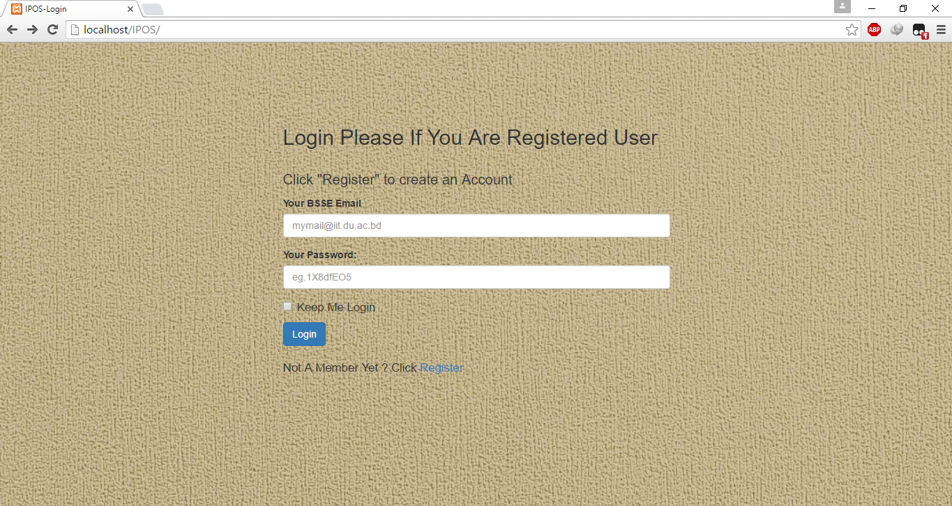

Figure 27 : Login Page

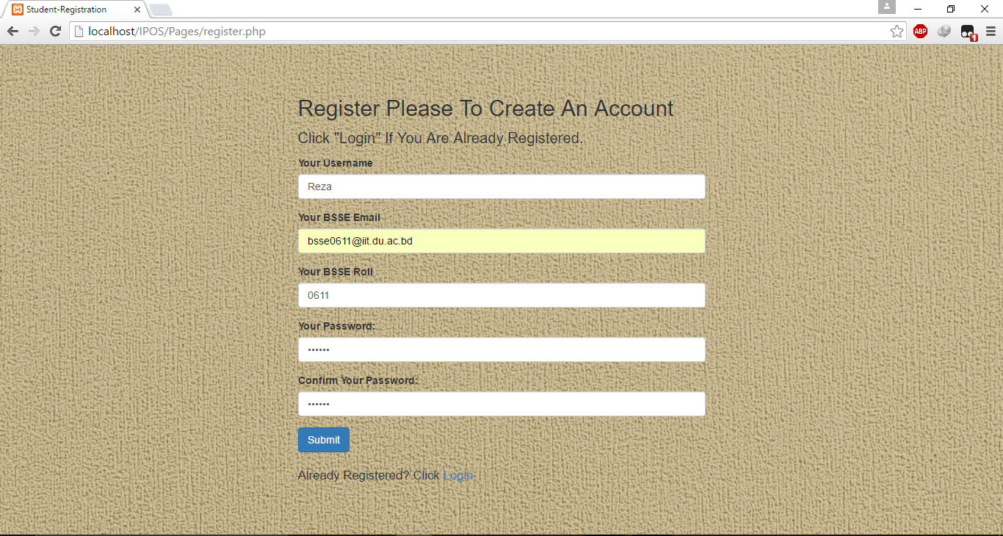

Figure 28 : Student Registration

This page comes when student click the link “Register”.

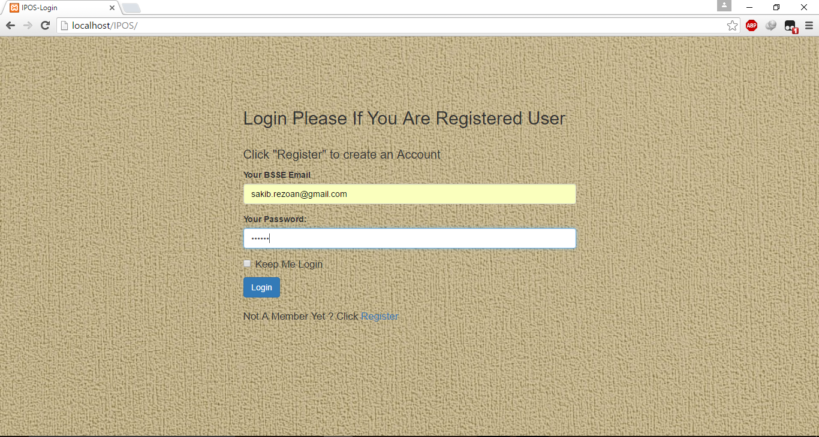

Figure 29: IPOH Login



Figure 30: Home Page for IPOH

This page comes when the IPOH login to the system. H/Se is super admin of the system and only h/se can view the admin panel.

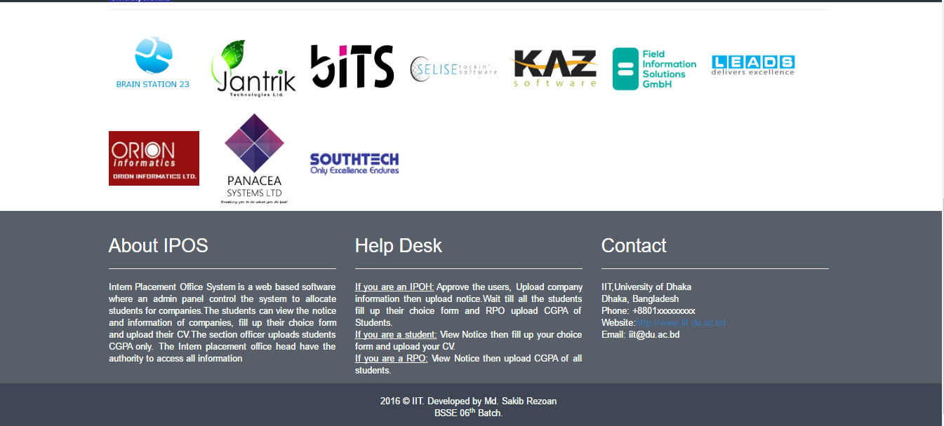

Figure 31: Footer

This is the footer for all the pages.

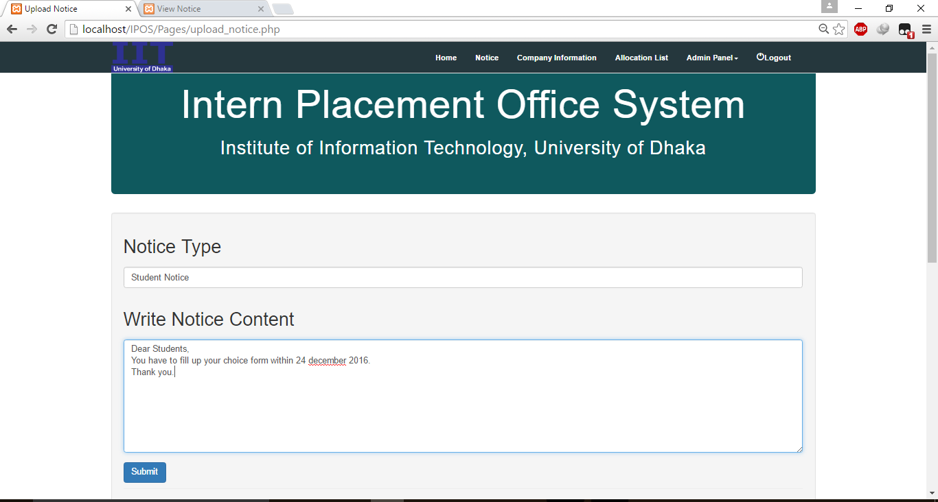

Figure 32: Notice Uploading by IPOH

This pages comes when the IPOH clicks the “Upload Notice” button of “Admin Panel”.

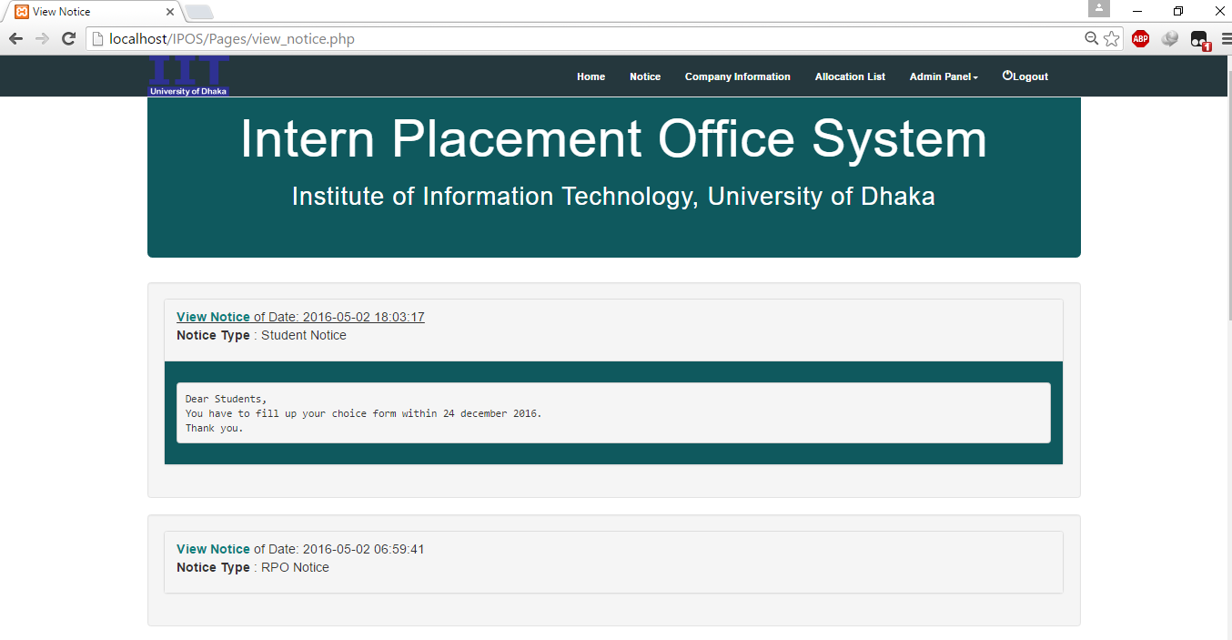

Figure 33: View Notice

This page comes when IPOH wants to view the uploaded notice and clicks the “Notice” button.

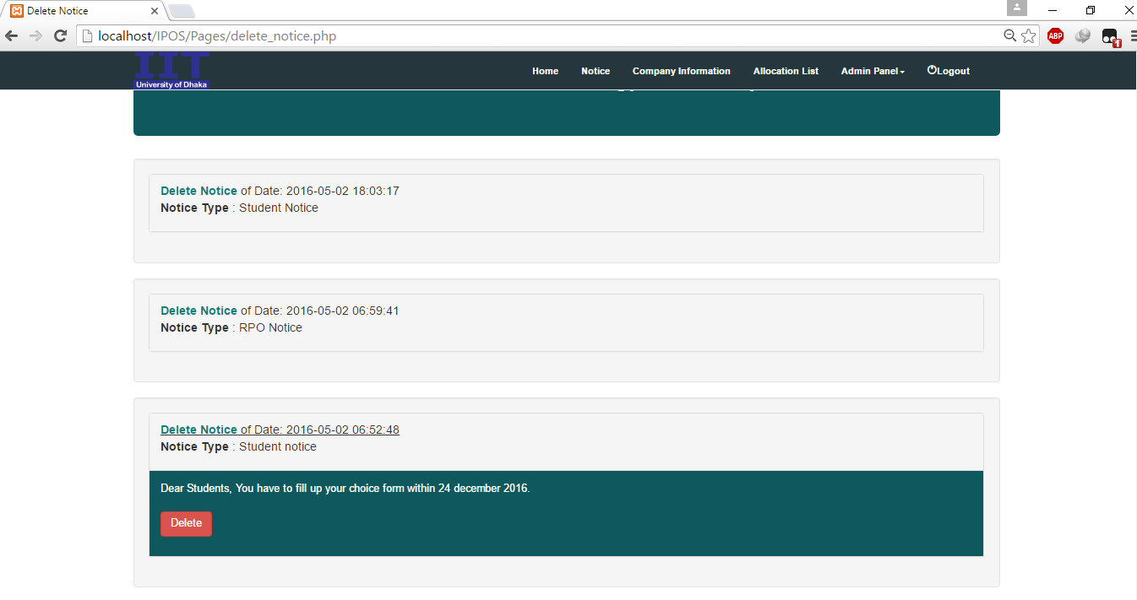

Figure 34: Deleting a notice

This page comes when the IPOH wants to delete a notice and clicks “Delete Notice” button from “Admin Panel”.

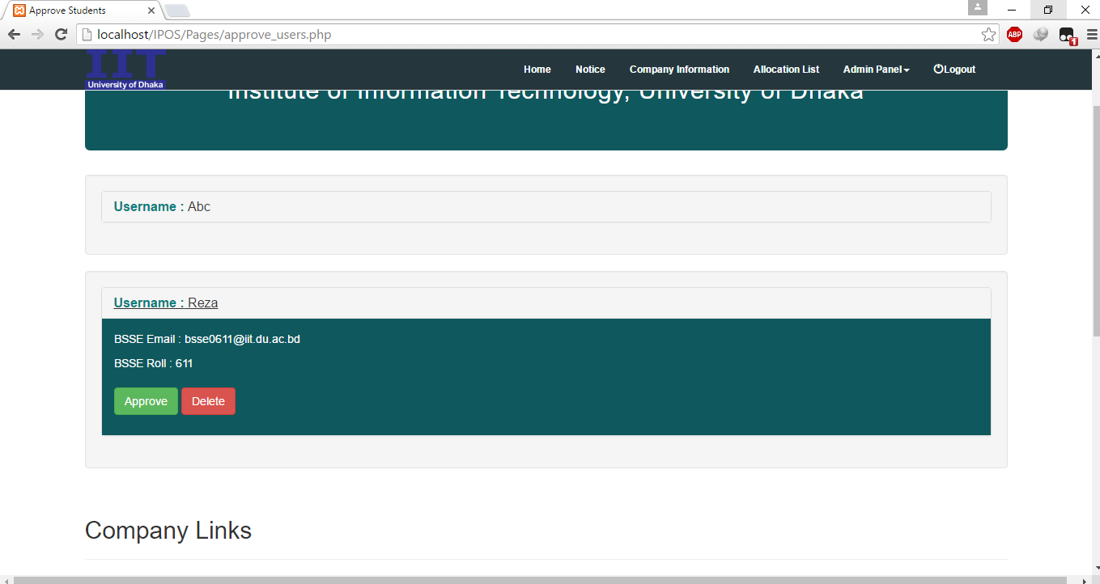

Figure 35: Approve students

This page comes when the IPOH clicks “Approve User” button from “Admin Panel” to approve the student for the system to login. If the IPOH doesn’t want to approve any student h/she just can press the “Delete” button to delete the student.

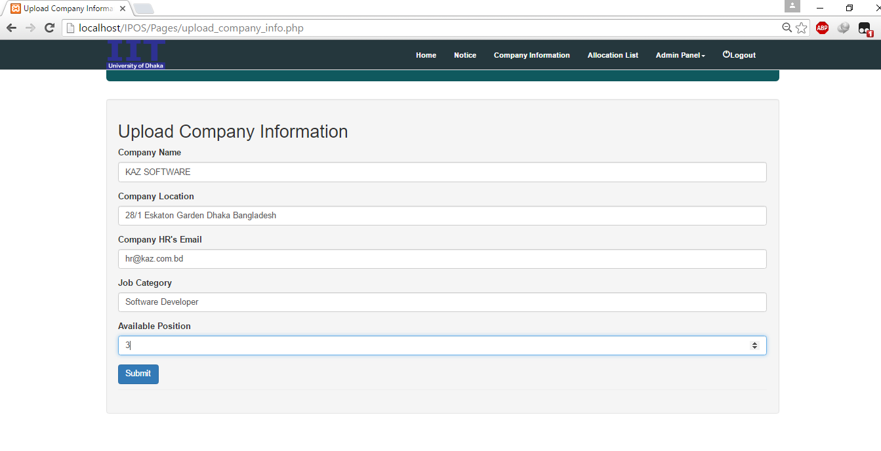

Figure 36 : Uploading company information

This page comes when the IPOH clicks “Upload Company info” button from “Admin Panel” to upload the information of companies.

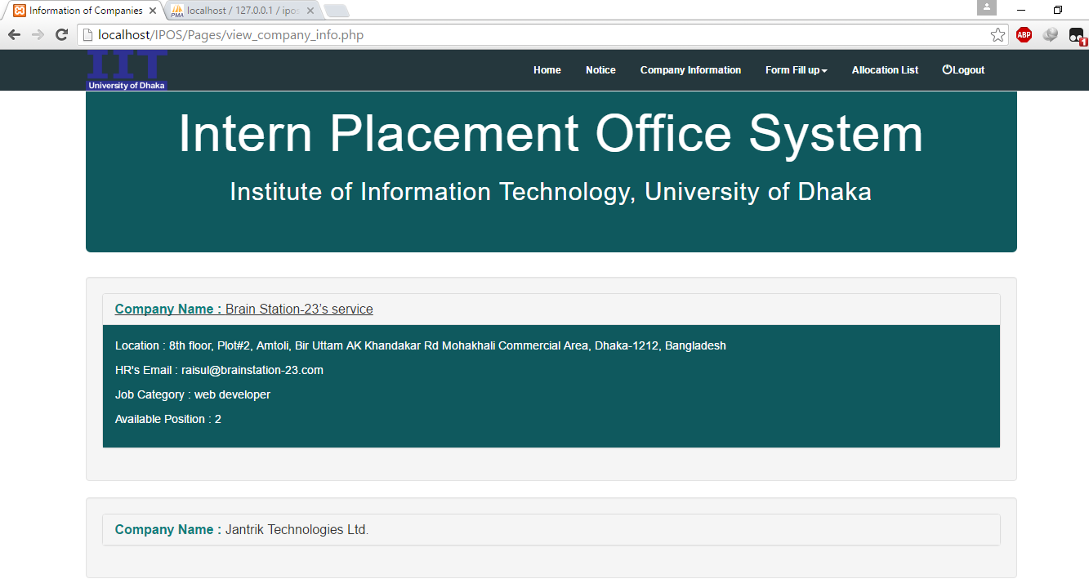

Figure 37: View company information

This page comes when student or IPOH want to view company information by clicking “Company Information” button.

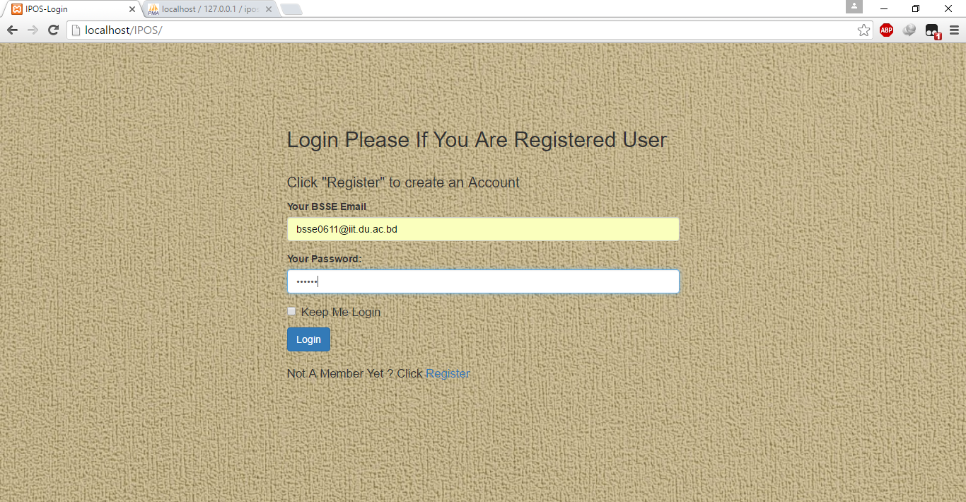

Figure 38: Student Login

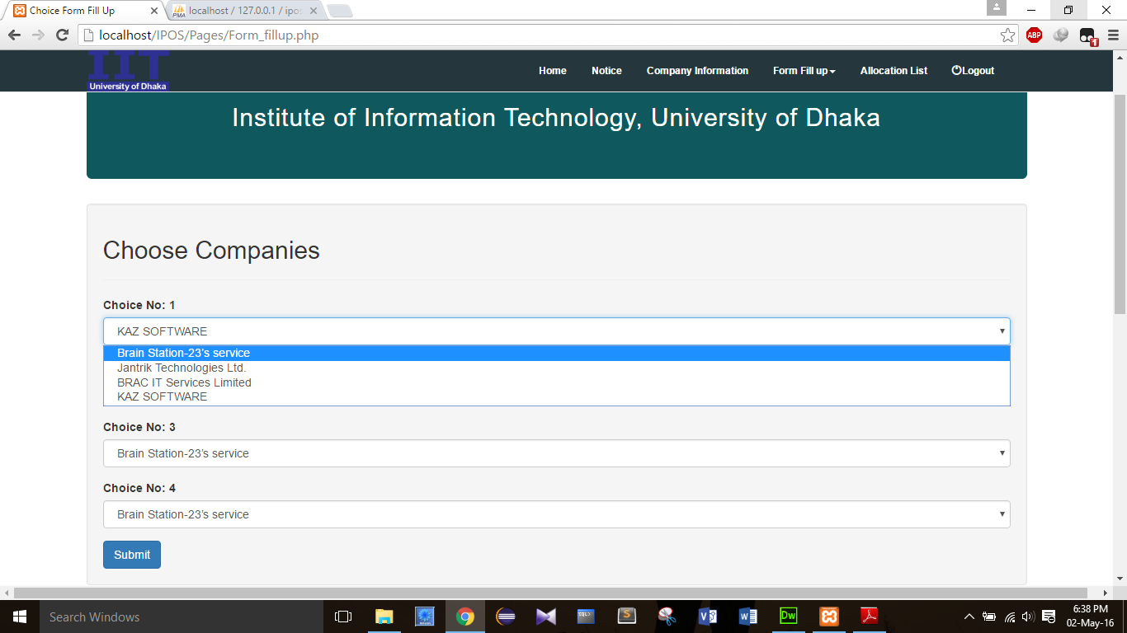

Figure 39 : Choice Form Fill up of Students

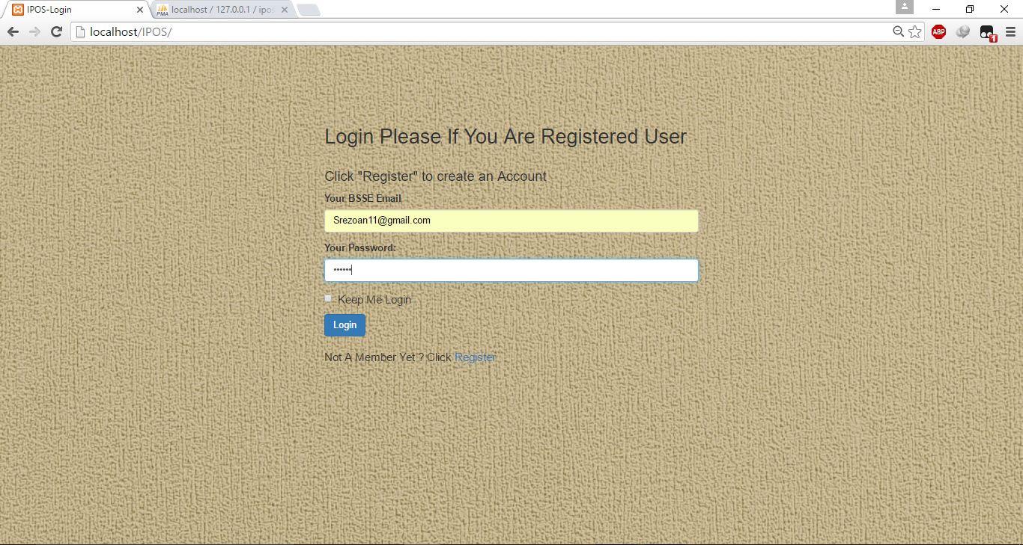

Figure 40 : RPO Login

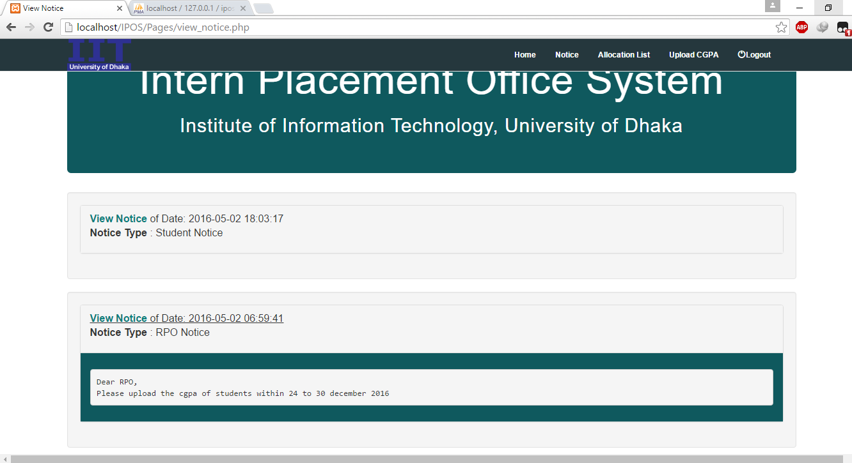

Figure 41: RPO Notice

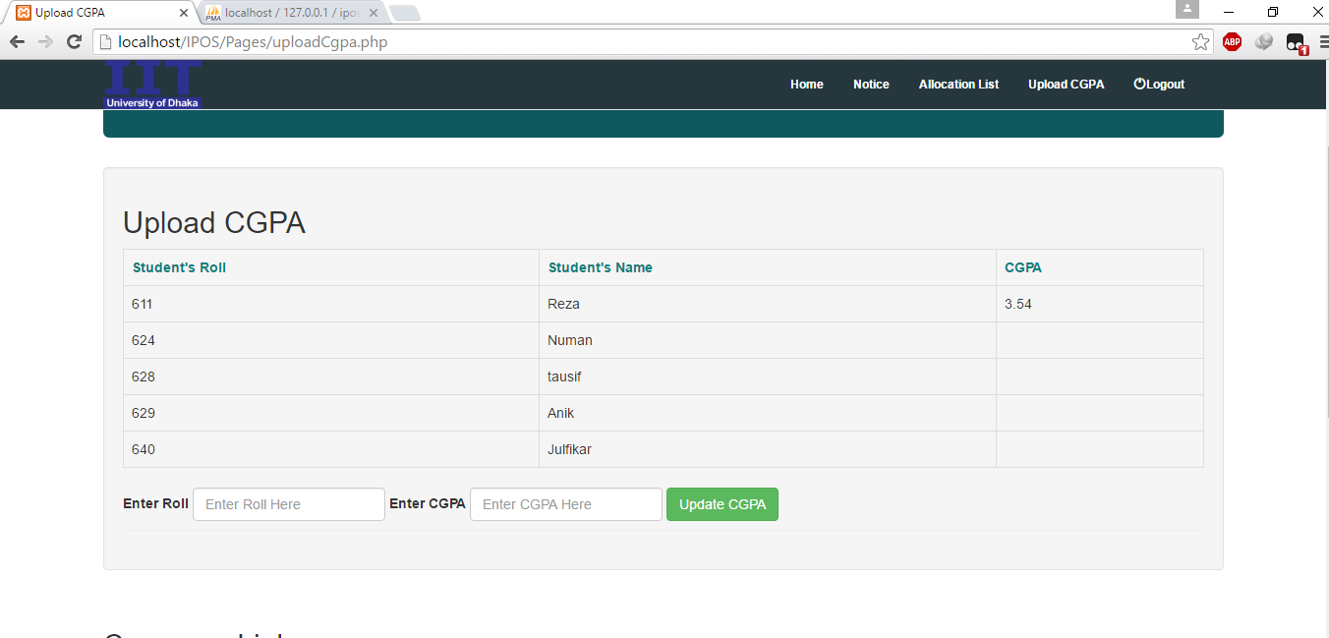

Figure 42: Uploading CGPA by RPO

This page comes when RPO wants to enter the CGPA of students by clicking “Upload CGPA” button.

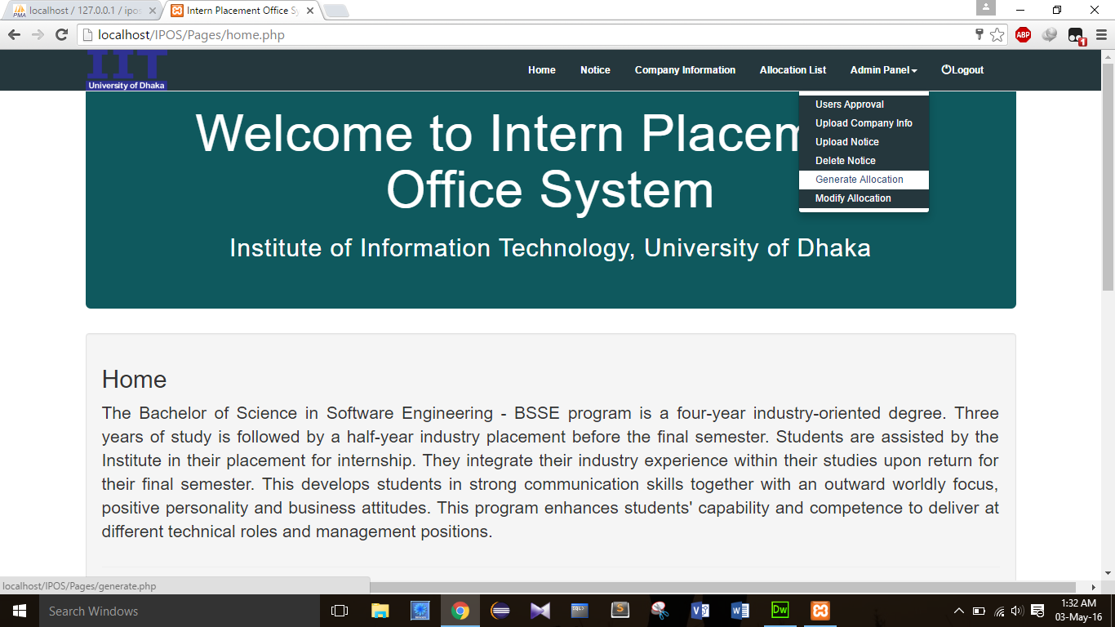

Figure 43 : Generating Allocation List by IPOH

IPOH generate an allocation list based on student’s CGPA by clicking “Generate Allocation” Button.

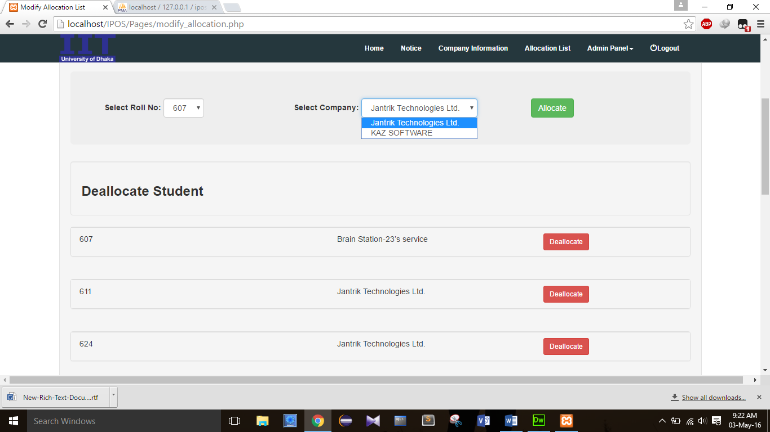

Figure 44:Modify Allocation

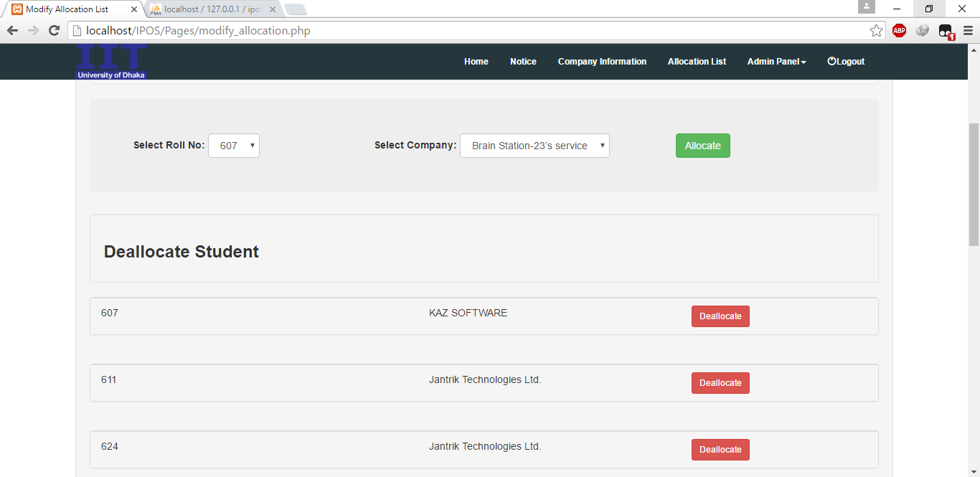

Figure 45 : After Modify Allocation List

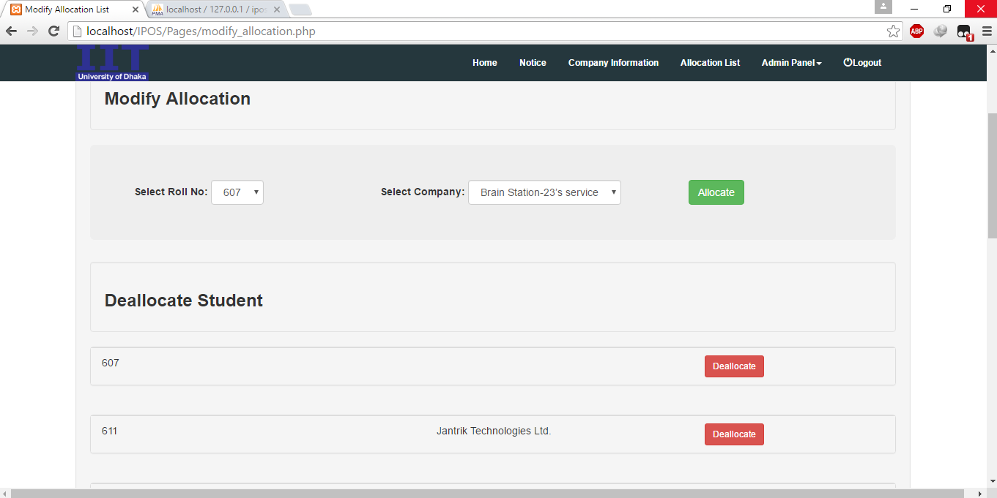

Figure 46 : Deallocate a student

# Chapter 9 Conclusion

I am pleased to submit the final SRS report on Intern Placement Office System. From this, the readers will get a clear and easy view of Intern Placement Office System of IIT, DU. This SRS document can be used effectively to maintain software development cycle. It will be very easy to conduct the whole project using this SRS. I tried my best to remove all dependencies and make effective and fully designed SRS. I believe that reader will find it in order.

**References:**

1. Software Engineering: A Practitioner’s Approach by Roger Pressman
2. Ralph, Paul (2012). "The Illusion of Requirements in Software Development". Requirements Engineering
3. Summerville, I. Software Engineering, 7th ed. Harlow, UK: Addison Wesley, 2006
4. <http://www.tutorialspoint.com/dbms/er_diagram_representation.htm>